**To revise:**

**Super Admin:**

1. Ilipat ang sidebar sa taas.

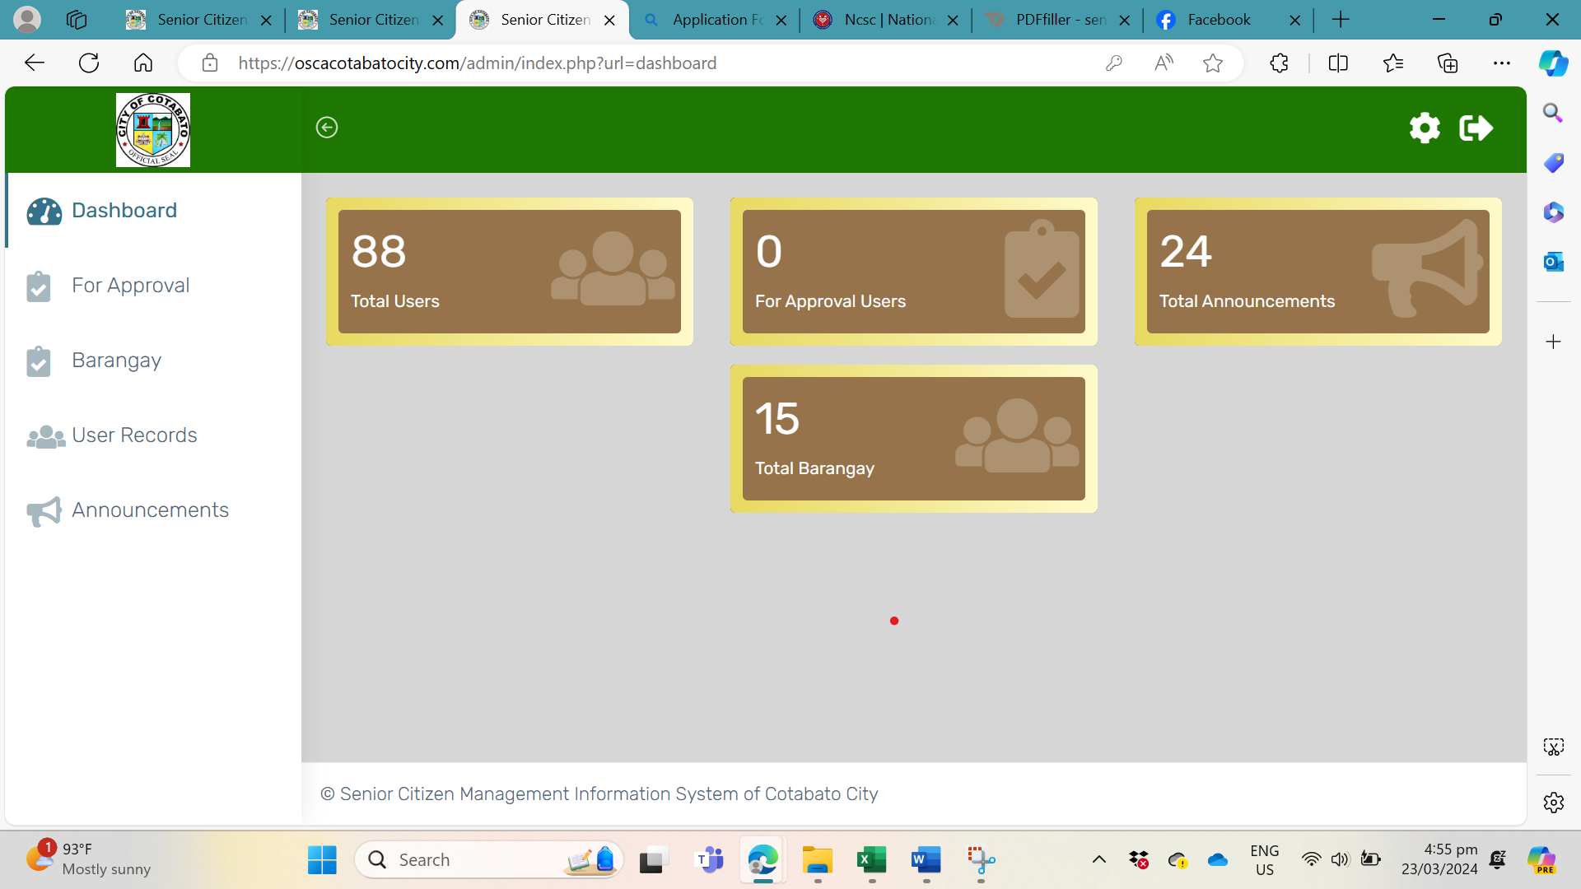

**Dashboard For Approval Barangay User Records Announcements News and Events**

1. Lahat ng users, dapat pwede ma-arrange alphabetically
2. Sort ang “With Pension at Without Pension” Palitan ang EMAIL ng PENSION STATUS (Y or N lang madisplay) Note: Ganito din sa User Records per Barangay

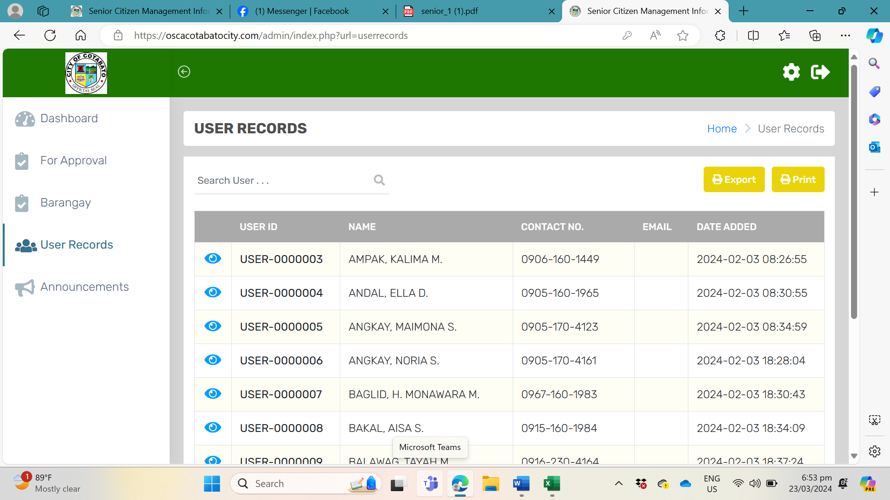

**PENSION STATUS**

Y

N

N

Y

Y

Y

y

1. **Add:** News and Events na pwedeng i-add, i-update and delete ni Admin. Then magshow up xa sa landing page ng Barangay Page (gawin na lang background and picture ng City Hall)

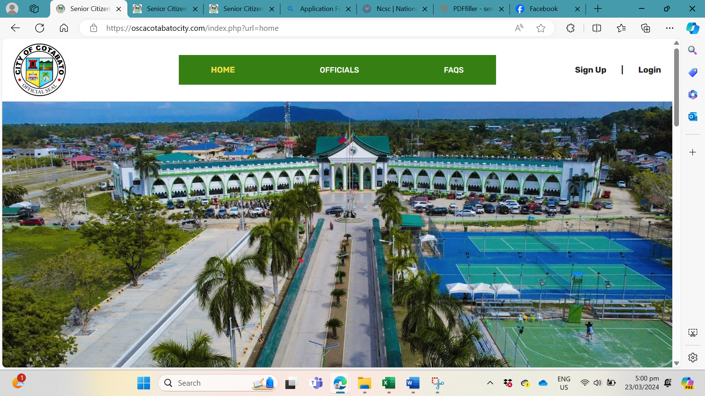

News and Events

**Employee:**

1. **HOME:**

Maglagay ng editable na News and Events instead of picture ng City Hall (si Super Admin ang mag-upload at delete ng News and Events)

1. LOGIN:

User Records: Dapat ma-sort alphabetically ang list ng users.

Dapat ma-sort ang “With Pension” sa Without Pension”

Change yung EMAIL sa PENSION STATUS (then Y or N lang, stands for Yes and No)

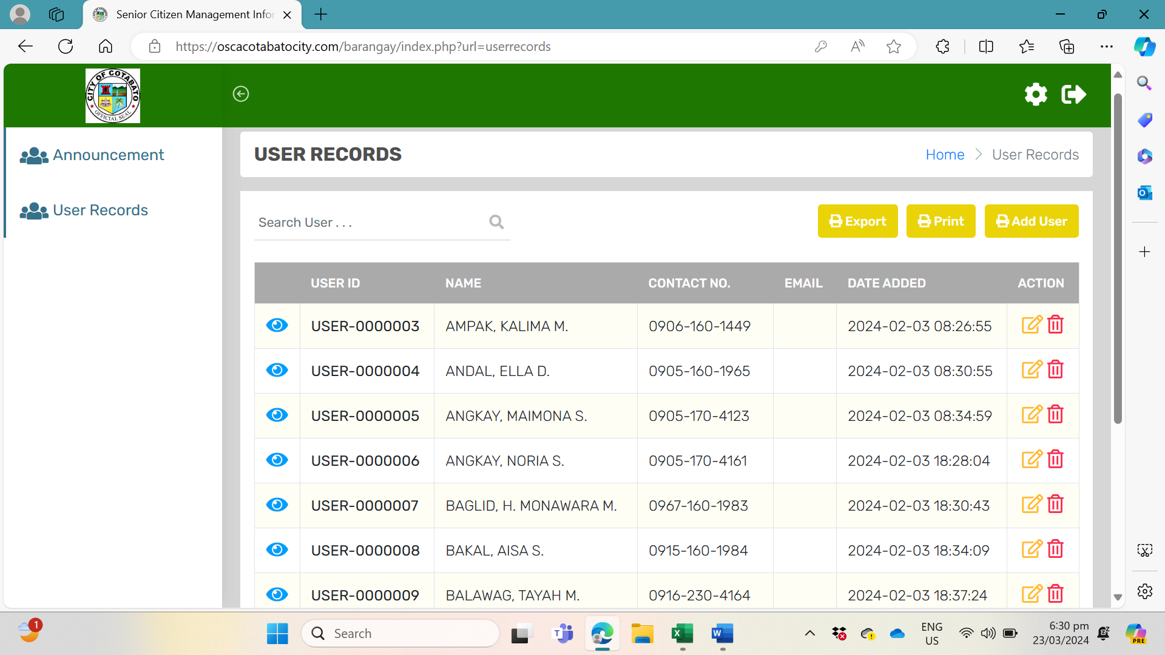

PENSION STATUS

1. **Add User**

3.1 Add: Upload Birth Certificate and 1 valid ID

3.2 Birthday and Age: Dapat restricted sa 60 years old above ang pwede

iencode, kapag below 60, dapat may prompt na “Invalid”

* 1. Palitan ang contents ng Basic Profile ng:

|  |  |  |  |
| --- | --- | --- | --- |
| First Name | Middle Name | Surname | Name Extension (Jr, I, etc.) |
| Address |  |  |  |
| Date of Birth | Age | Place of Birth | Marital Status |
| Contact Number | Religion | With Pension (Yes or No) |  |
| In Case of Emergency:  Name: |  | Contact Number |  |
| Upload Documentary Requirements: |  | Birth Certificate | Any Valid ID |

,

1. Alisin and side bar, ilipat sa taas.

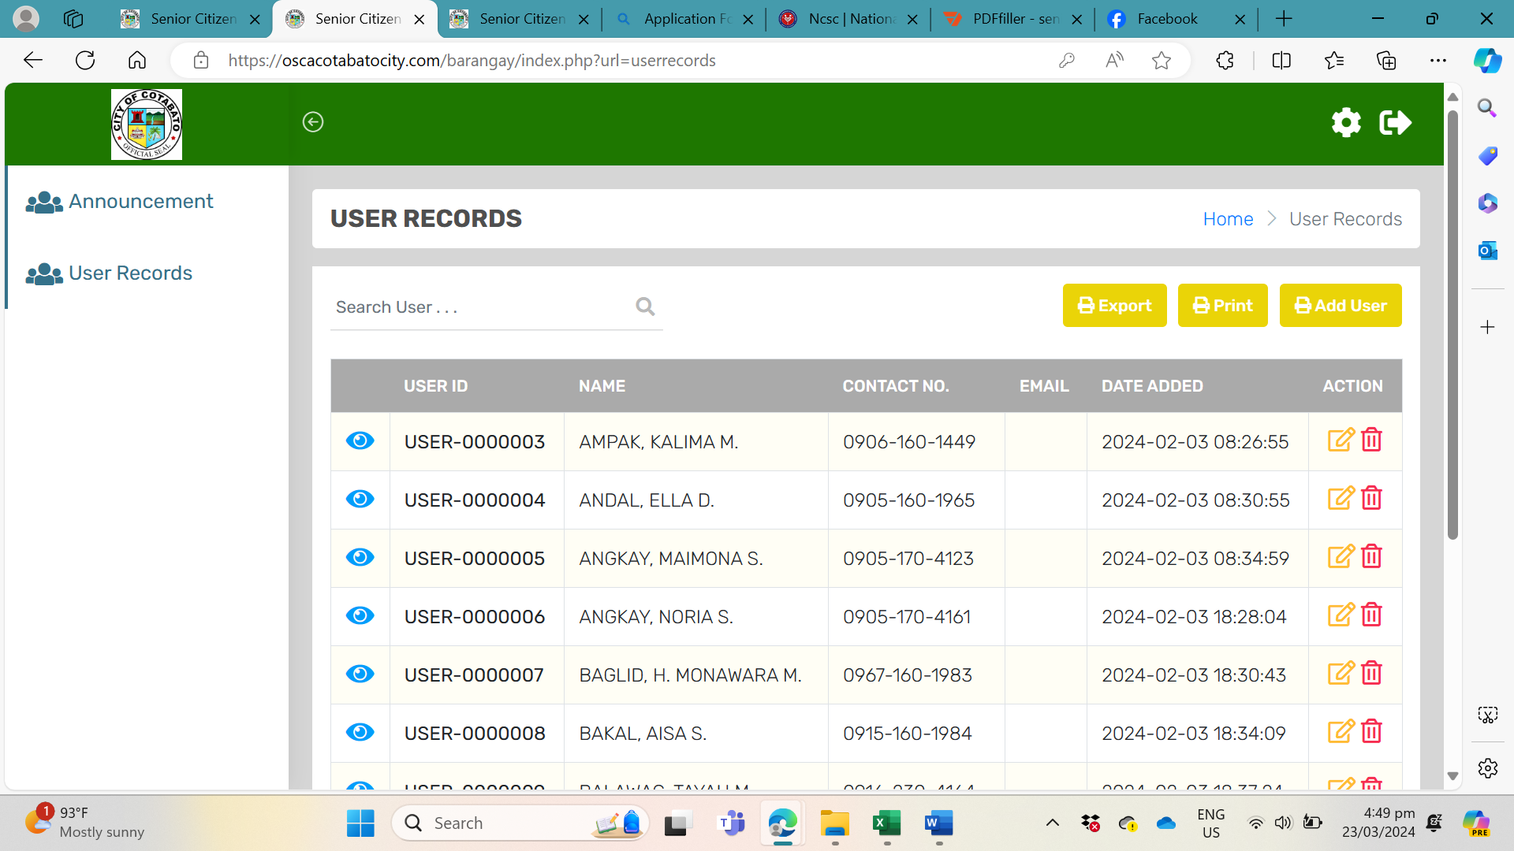

**Announcements User Records**